Janice Ainembabazi

Southern New Hampshire University

CS-340-18683-M01 Client/Server Development

Prof. Jeff Sanford

December 22nd 2024

1. Using the mongoimport tool, create the database “companies” by loading the documents found in the “companies.json” file into the “research” collection. This file is located in the “/usr/local/datasets/” directory in Apporto.

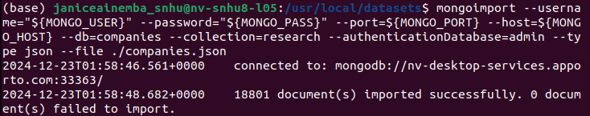

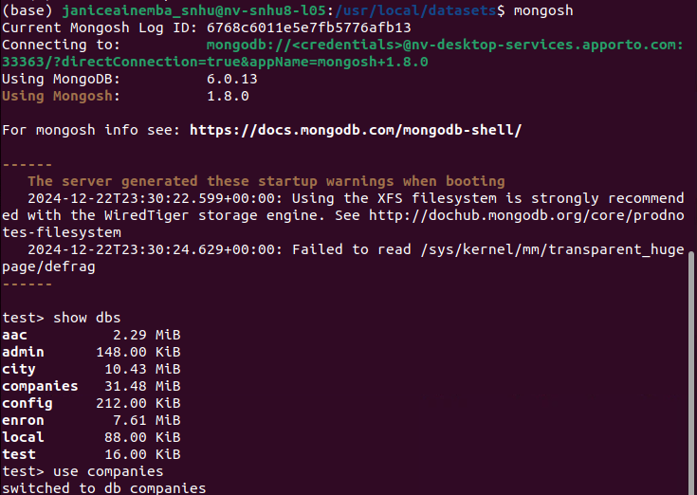

* Verify your load by issuing the following queries:

1. db.research.find({"name" : "AdventNet"})
2. db.research.find({"founded_year" : 1996},{"name" : 1}).limit(10)

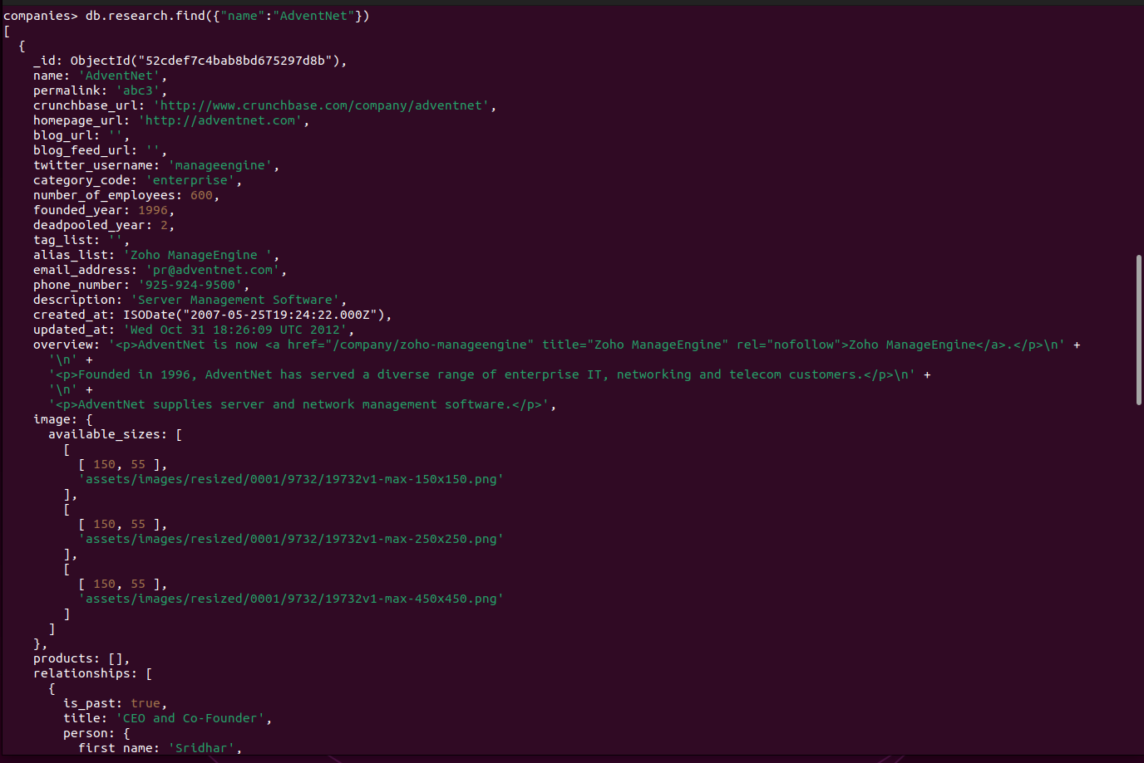

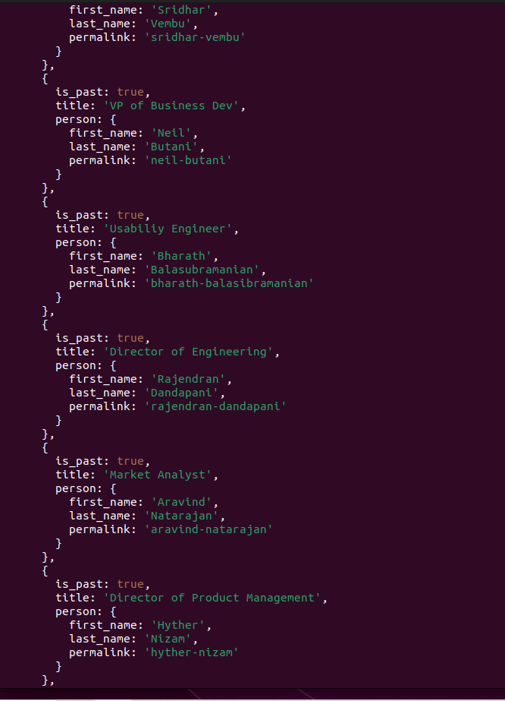

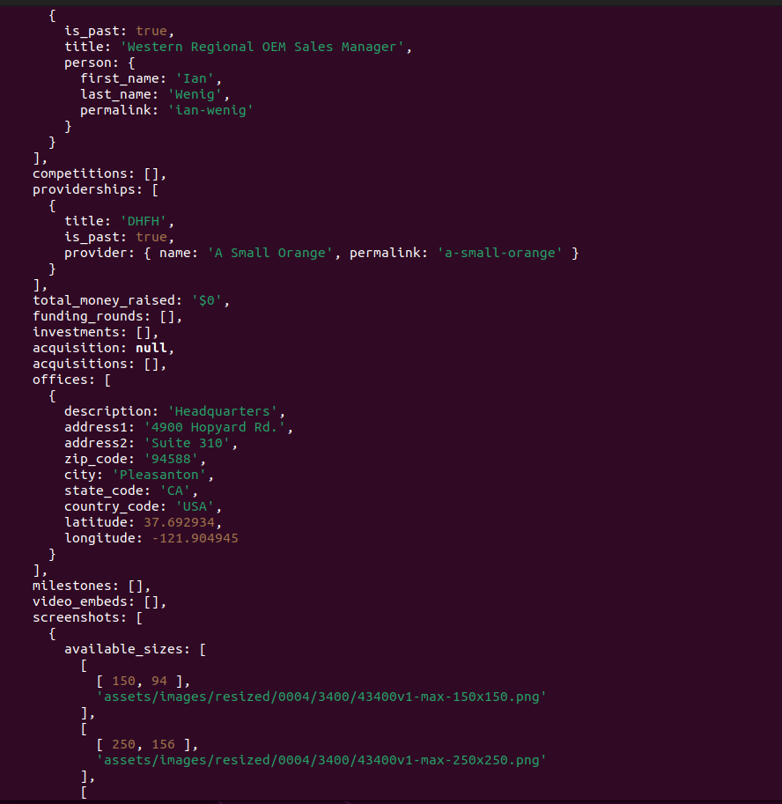

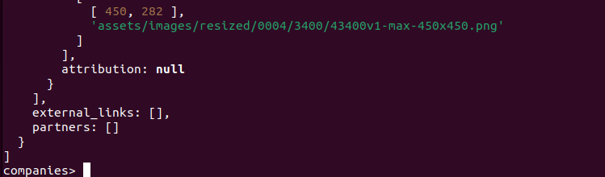

Perform the following tasks **using MongoDB queries**:

1. List only the first 20 names of companies founded after the year 2010, ordered alphabetically.

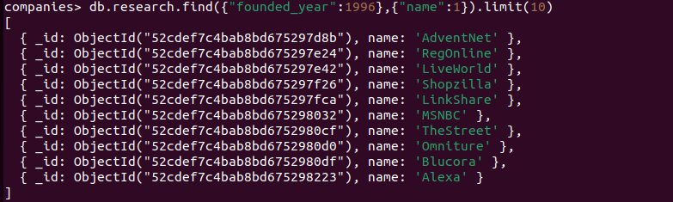

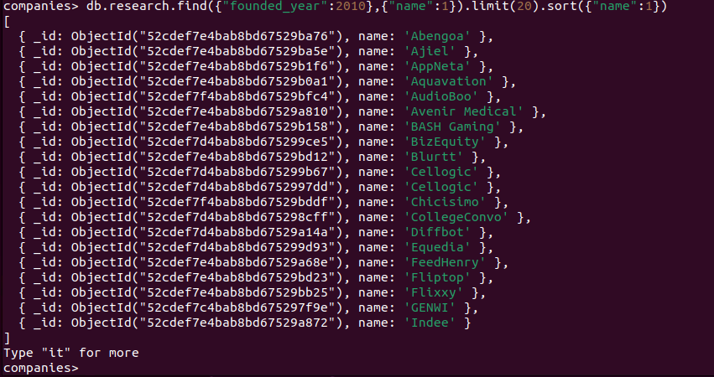

1. List only the first 20 names of companies with offices in either California or Texas, ordered by the number of employees and sorted largest to smallest.

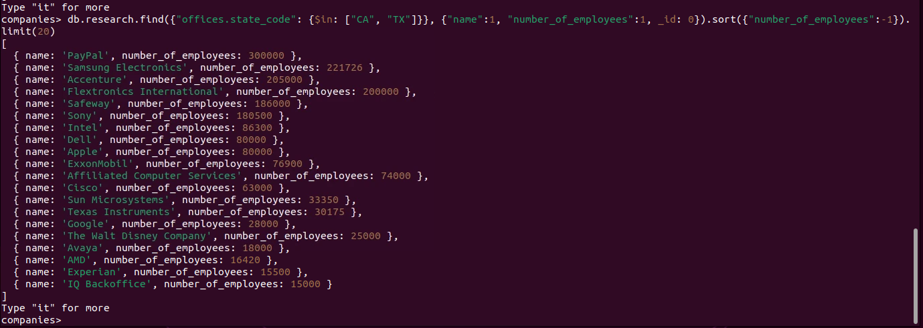

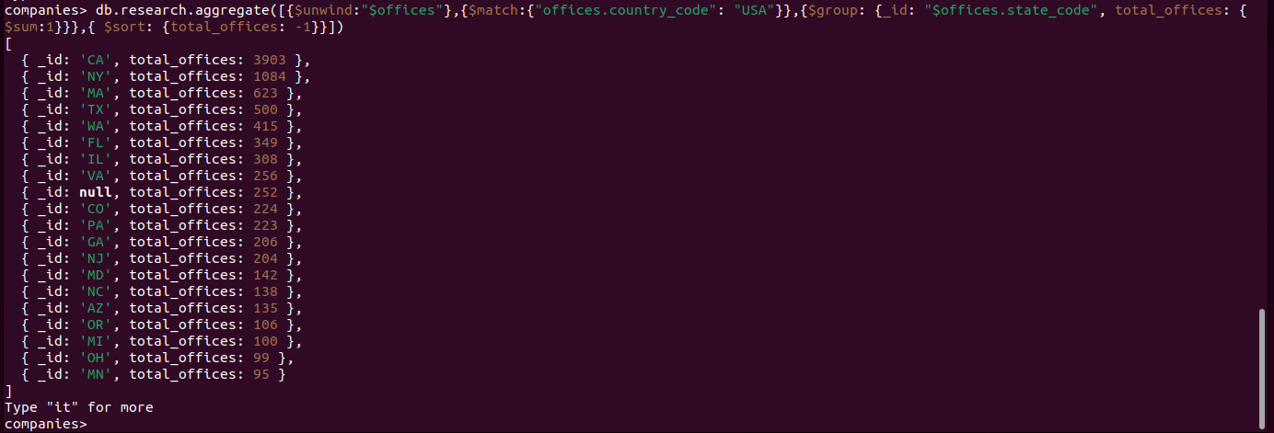

**Explanation of the pipeline:**

* $unwind: Breaks the offices array into separate documents.
* $match: Filters for offices located in the United States.
* $group: Groups by the state field and sums the total number of offices.
* $sort: Orders the results by the total number of offices in descending order.